Experiment No.: 6
Title of the Experiment:
Implementation of Stack using (a) Arrays and (b) Linked List

2. Mapped Objective and Mapped Outcome
Sr. No. | Mapped Course Objective (CO) | Mapped Course Outcome (CO No.)
2 | To implement stack operations using arrays and linked list dynamically. | CO3: Apply appropriate data structures to solve computational problems efficiently.

3. Software and Tools Used
- Language Used: C++
- Compiler: GCC / Turbo C++ / Code::Blocks
- Operating System: Windows / Linux

4. Brief Theory, Algorithm / Flowchart
Theory:
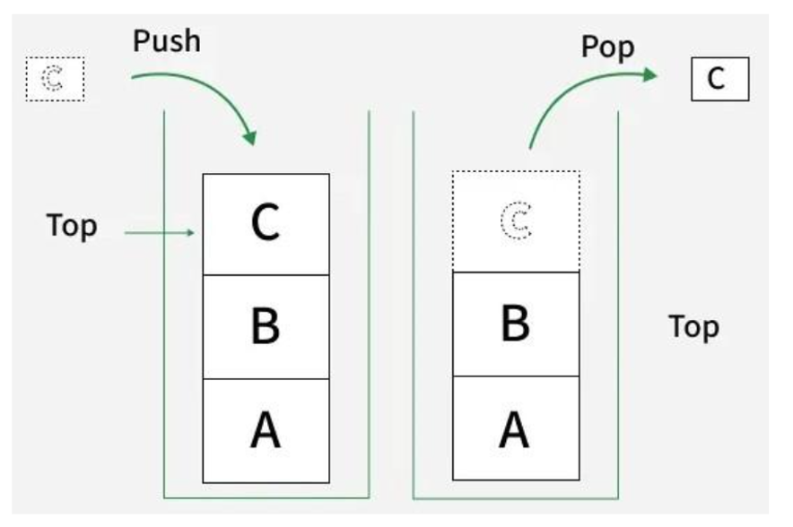
A Stack is a linear data structure that follows the LIFO (Last In, First Out) principle.
This means that the element inserted last is removed first.
Basic operations performed on a stack are:
- Push: Insert an element into the stack.
- Pop: Remove the topmost element.
- Peek/Top: Retrieve the top element without removing it.
- Display: Display all elements of the stack.
A stack can be implemented in two ways:
- Using Arrays (static implementation)
- Using Linked Lists (dynamic implementation)

A) Stack Implementation Using Array
Algorithm:
1. PUSH (Add Element):
- Check if top == MAX - 1.
If yes, Stack Overflow.
- Else, increment top by 1.
- Insert element at stack[top].
2. POP (Remove Element):
- Check if top == -1.
If yes, Stack Underflow.
- Else, print stack[top] and decrement top.
3. DISPLAY:
- If stack is empty, print “Stack is empty.”
- Else, print elements from top to 0.

Program Code (Using Array):
#include <iostream>
using namespace std;

#define MAX 5

class StackArray {
int stack[MAX];
int top;

public:
StackArray() {
top = -1;
}

void push(int value) {
if (top == MAX - 1) {
cout << "Stack Overflow!" << endl;
return;
}
stack[++top] = value;
}

void pop() {
if (top == -1) {
cout << "Stack Underflow!" << endl;
return;
}
cout << "Popped Element: " << stack[top--] << endl;
}

void display() {
if (top == -1) {
cout << "Stack is empty." << endl;
return;
}
cout << "Stack elements: ";
for (int i = top; i >= 0; i--)
cout << stack[i] << " ";
cout << endl;
}
};

int main() {
StackArray s;
s.push(10);
s.push(20);
s.push(30);
s.display();

s.pop();
s.display();

return 0;
}
Sample Input and Output (Array Implementation):
Operation | Input | Output
Push | 10, 20, 30 | Stack elements: 30 20 10
Pop | - | Popped Element: 30
Display | - | Stack elements: 20 10

B) Stack Implementation Using Linked List
Algorithm:
1. PUSH (Insert Element):
- Create a new node.
- Assign data to new node.
- Set newNode->next = top.
- Update top = newNode.
2. POP (Delete Element):
- If top == NULL, print “Stack Underflow.”
- Else, store top in temp, move top = top->next, print deleted element, and delete temp.
3. DISPLAY:
- If top == NULL, print “Stack is empty.”
- Else, traverse from top to NULL and print each node’s data.

Program Code (Using Linked List):
#include <iostream>
using namespace std;

class Node {
public:
int data;
Node* next;
};

class StackLinkedList {
Node* top;

public:
StackLinkedList() {
top = NULL;
}

void push(int value) {
Node* newNode = new Node();
newNode->data = value;
newNode->next = top;
top = newNode;
}

void pop() {
if (top == NULL) {
cout << "Stack Underflow!" << endl;
return;
}
Node* temp = top;
cout << "Popped Element: " << top->data << endl;
top = top->next;
delete temp;
}

void display() {
if (top == NULL) {
cout << "Stack is empty." << endl;
return;
}
Node* temp = top;
cout << "Stack elements: ";
while (temp != NULL) {
cout << temp->data << " ";
temp = temp->next;
}
cout << endl;
}
};

int main() {
StackLinkedList s;
s.push(10);
s.push(20);
s.push(30);
s.display();

s.pop();
s.display();

return 0;
}
Sample Input and Output (Linked List Implementation):
Operation | Input | Output
Push | 10, 20, 30 | Stack elements: 30 20 10
Pop | - | Popped Element: 30
Display | - | Stack elements: 20 10

6. Conclusion
In this experiment, we implemented the Stack data structure using both Arrays and Linked Lists in C++.
We performed basic stack operations such as Push, Pop, and Display.
The array-based implementation uses static memory allocation, while the linked list implementation uses dynamic memory allocation.
This experiment demonstrates the concept of LIFO (Last In, First Out) and helps understand differences between static and dynamic stack implementations.

